Customizing Your Big Day Card

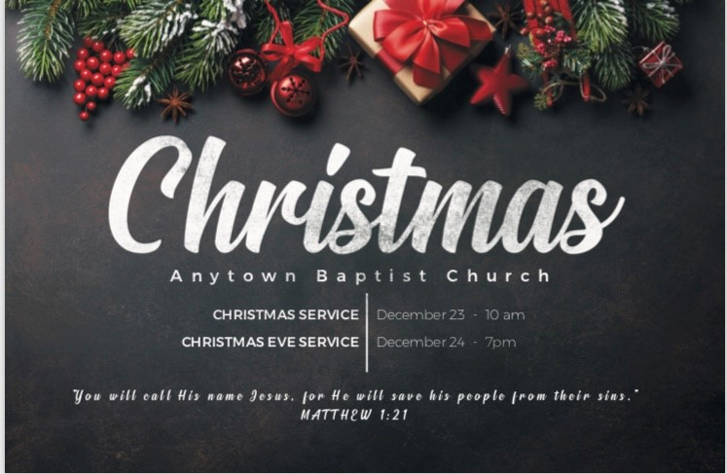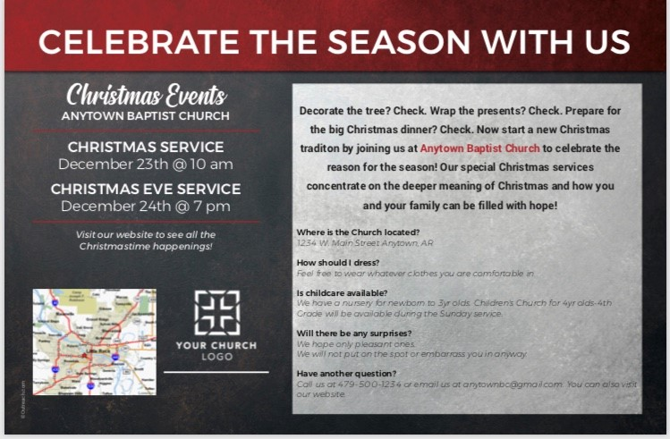
Front Back

Information for ordering customizable Christmas invitations (such as the one above):

Choosing the design to customize:
  - Go to www.outreach.com. In the red line near the top of page, hover the curser over “Postcards” on the far left and a drop down menu will appear.
  - The drop down menu will give you options.
  - Choose “Custom 8.5 x 5.5.”
  - When that page opens, click on “Christmas” in the left column and several Christmas designs will appear.
  - Choose the style you want.
  - A webpage will open allowing you to begin the customizing process.

Customizing the card:
- Select the quantity you want to order (you can adjust the quantity before placing final order).
- Determine whether the cards will be mailed or handed out and make that selection.
- Click “Next: Customize Online.” (NOTE: Customizing the card requires Adobe Flash. At some point in the editing process, you may be required to download or activate Adobe Flash to proceed).
- A webpage opens that allows you to customize the card to fit your church.
- The level of customization on the front of the card depends on the specific design you choose.
- The back of the card is highly customizable. You can add a map, church logo, time, address, questions guests might ask, and even the message to match your church’s need. (You can delete the map and logo space if you choose not to include those.)
- Once you have finished customizing the card, click “Save” at the top of the screen. If you have not already created an account, you will be required to do so at that time.
- Once saved, click “Download Proof” at the top of the page.
- Review the proof.
- Once all edits have been finalized, click “Done” at the top left of the editing webpage.
- Finalize the quantity of cards to order and place order (verify that shipping dates will allow you to receive and distribute the cards before your Big Day).

For questions about ordering customizable cards, contact Outreach.com at (800) 991-6011.

