**Inspire Breakout Session**

**Titles/Descriptions/Bios**

***Beyond the Insta-Life***

**Jill McSheehy**

What if you could break through the restless mundane of everyday life and start living a life of invigorating purpose? Discover how in this eye-opening exploration of the heart of God for our lives tucked into Isaiah 58.

***A member of First Baptist Church Russellville and stay-at-home mom to two school-aged children, Jill McSheehy divides her time between teaching and writing Bible studies and teaching beginners how to garden. She has published two Bible studies — Journey through Acts and Journey to Freedom — and hosts a weekly podcast, the Beginner’s Garden. Connect with Jill at*** [***journeywithjill.net***](http://journeywithjill.net/)***.***

***Families that Blaze with Holiness***

**Renee Crosse**

“Let yourselves be pulled into a way of life, energetic and blazing with Holiness.” (I Peter 1:15) Join Renee as she encourages *Inspire* attendees to have marriages and families that are RADIANT with the love and light of Jesus Christ.

***Renee Crosse is a wife, mom, author and speaker. She has been married to Clay Crosse since 1990. They are members of First Baptist Bentonville, where she teaches Bible study and her husband serves as worship pastor. Clay and Renee are the founders of HolyHomes Ministries. They speak at churches as well as marriage and family conferences. Renee seeks to encourage others to have lives, marriages and homes that radiate with the love of Christ.***

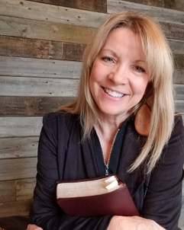

***Entrusted Influence:* Encouragement for Ministers’ Wives**

**Cheryl Harp**

Join Cheryl as she shares in this session for ministers’ wives only and discusses what has God entrusted to you for His radiant joy?

***Cheryl Harp is the pastor's wife at Lakeview Baptist Church, Cave Springs and considers that to be her great joy and blessing. She ministers to women in the local church as the Women's Ministry Team Leader and she also serves as the NWA Women's Ministry Network Volunteer for the Arkansas Baptist State Convention. She loves to dig into scripture, write bible studies and teach women and young couples study groups. Ministry, along with two completely adorable grandbabies, keeps her extremely busy but that is fully where her passion is. She is forever humbled and grateful that God allows her to be a part of His awesome work.***



***Radiant Joy Among Unreached Peoples***

**Jamie Naramore**

The nations are coming to us, and women who radiate the joy of Christ are already equipped with everything they need to reach them through their homes, hobbies, and workplaces! Come learn with us how you can display and declare the joy of Jesus among Unreached People Groups in Arkansas.

***Jamie Naramore serves as the International Church Strategist for the Arkansas Baptist State Convention, helping churches plant churches among Unreached People Groups in Arkansas while helping every church member see themselves as missionaries to every nation. He has served among Muslims in a variety of contexts both locally and globally, during which he has fostered the spiritual gifts of storytelling and coffee drinking.***

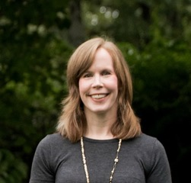***Changing Your Mind:* How to Radiate Joy**

**Angela Mackey**

Joy is a fruit of the Spirit – it cannot be cultivated in soil devoid of nutrients, oxygen, or Son-light. In this session you will be challenged to rethink your thinking so you can radiate the joy of Christ no matter what circumstances you face.

***Angela Mackey is a self-proclaimed stumbling child of God, wife, and mother who longs to make much of her Savior. With over eighteen years of experience teaching God’s Word, Angela challenges her audiences to rethink their thinking in light of God’s Word so they can live transformed lives. Angela received her Master’s degree in Biblical and Theological Studies in 2016 and is a member of the John Maxwell Team as a speaker, trainer, and coach. Currently she teaches a leadership class at Union Christian Academy, is their school nurse, and is an assistant martial arts instructor. Down-to-earth and practical, Angela encourages and challenges women to cling to God at all times. You can find her at her blog Rethinking My Thinking*** [***www.rethinkingmythinking.com***](http://www.rethinkingmythinking.com) ***or on Facebook*** [***www.facebook.com/RethinkingMyThinking***](http://www.facebook.com/RethinkingMyThinking)***.***

***Walking in the Power of the Holy Spirit***

**Marian Jordan Ellis**

We can shine bright for Jesus as we walk in the power of the Holy Spirit. Who is the Holy Spirit? How can we access His power? What practical steps lead us to walk in step with the Holy Spirit? These questions will be asked and answered. A radiant woman is always connected to her power source!

***Marian Ellis is the founder of Redeemed Girls Ministries. She is an active Bible study teacher, conference speaker and published author. She is a graduate of Southwestern Baptist Theological Seminary. Marian lives in San Antonio with her husband Justin, their three children and one very spoiled dog, London.***

***Engaging the Next Generation***

**Jennifer Mills & Jennifer Frances**

Living out an everyday life of authenticity and availability gives us the privilege to speak into the next generation. We will discuss how this plays out in our personal lives through intentionally investing in the lives of younger women whom God places in our sphere of influence.

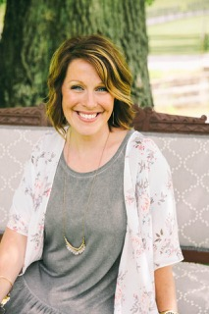

***Jennifer Mills is a speaker, writer, & Co-Author of “Salvaging My Identity” & “Even More”. She has a heart for studying and teaching the Word of God to girls and women of all ages and is passionate about seeing them fall in love with Jesus and learn to dig into God’s Word for themselves. She has been in full time ministry alongside her husband Brian for over sixteen years, serving in girl’s ministry, college ministry & teaching women’s Bible studies at her local church.***

***Jennifer & Brian have been happily married for 16 years and her “full-time job” is being mom to the two amazing kids - McKenna (14) & Parker (12). Jennifer and her family currently live in Fayetteville, AR, where her husband Brian serves as the College Pastor at Cross Church.***

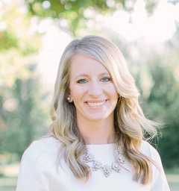

**Jennifer Frances** ***serves as Preschool & Women’s Ministry Director at Cross Church, Fayetteville. She holds a BA in Biblical Studies from Ouachita Baptist University. Jennifer is married to Josh and they have 2 wonderful kids - Brody and Jillian Kate - and they enjoy all that family life brings where they live in Northwest Arkansas. Jennifer loves encouraging women in Christ-centered spiritual growth opportunities in our shared journey of faith. She is passionate about knowing God and His word, and believes because we have experienced His unconditional love, we are positioned to share it with others. Jennifer seeks to lift up women as influencers in our homes, workplaces, neighborhoods, and communities, so we can strive to steward well the gifts and abilities we have been given by God.***

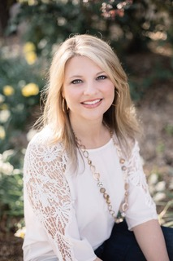***Reflecting His Glory***

**Andrea Lennon**

As we look to Jesus, our lives are radically transformed and result in shame free, guilt free, and beautiful lives. How can we look to Jesus during the busyness of life? Learn ten practical ways to focus on Jesus so you can reflect His glory!

***An “on the go” kind of girl who loves Jesus, Andrea is a Bible teacher whose life calling is to teach women to know the truth, live the truth, and share the truth. Her passion is honest conversation about the topics that drive our messy, everyday lives, and how we can always weather the storms through the love and power of God and His Word. Andrea is a 2004 graduate of Southwestern Baptist Theological Seminary. She has written and published several books and teaching DVDs that complement her books. Andrea hosts a weekly radio program called Truth on the Go with Andrea Lennon and a weekly podcast called Inspire on the Go. She serves as the Women’s Ministry Specialist for the Arkansas Baptist State Convention. Andrea lives in Conway, Arkansas with her husband, Jay, and two sons, Jake and Andrew. Connect with Andrea at*** [***www.andrealennonministry.org***](http://www.andrealennonministry.org)***.***

*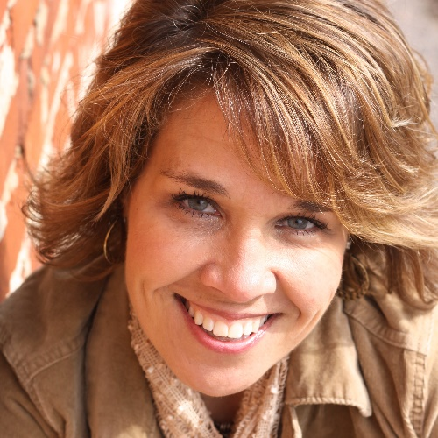****So Much Bigger Than You***

**Lori McDaniel**

It has been prearranged that your life declare a story. This narrative is intended to be nothing more and nothing less than an expression of God’s name and His glory. From Genesis to Revelation, God is on a mission to make much of His name. Your finite story fits into His infinite one. So, what in the world are you doing for God’s name?

***Lori McDaniel is a mom of 3, pastor's wife, speaker and works at the International Mission Board as manager of the Church Initiatives team. She served with her family as a missionary for several years in Africa before returning to plant Grace Point Church in Bentonville, Arkansas.***

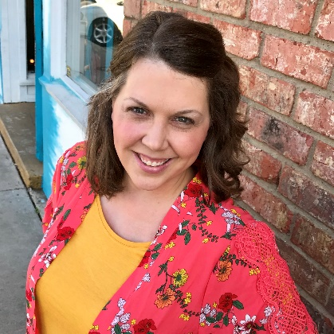***Living Your Best SOCIAL Life:* Inspiring Others Through Social Media**

**Keisha McKinney**

In today's world, social media has a bad reputation. But, what if the 3rd largest populated "country" could be a place that included the "end of the earth" when it comes to living out the Great Commission? Be encouraged to be a blessing through practical tips for social media you can use every day.

**Keisha (Pittman) McKinney lives in South Arkansas with her husband and sweet Boxer, Bailey and one-year-old son! Keisha is passionate about connecting people and building community, seeking solutions to the everyday big and small things, and encouraging others through the mundane, hard, and typical that life often brings. She put her communications background to work as a former Non-profit Executive Director, college recruiter and fundraiser, and Digital Media Director at a large church in Northwest Arkansas. Now she is using all of those experiences through McKinney Media Solutions and her blog @bigpittstop which includes daily adventures, cooking escapades, #bigsisterchats, the social justice cases on her heart, and all that she is learning as a #boymom!**