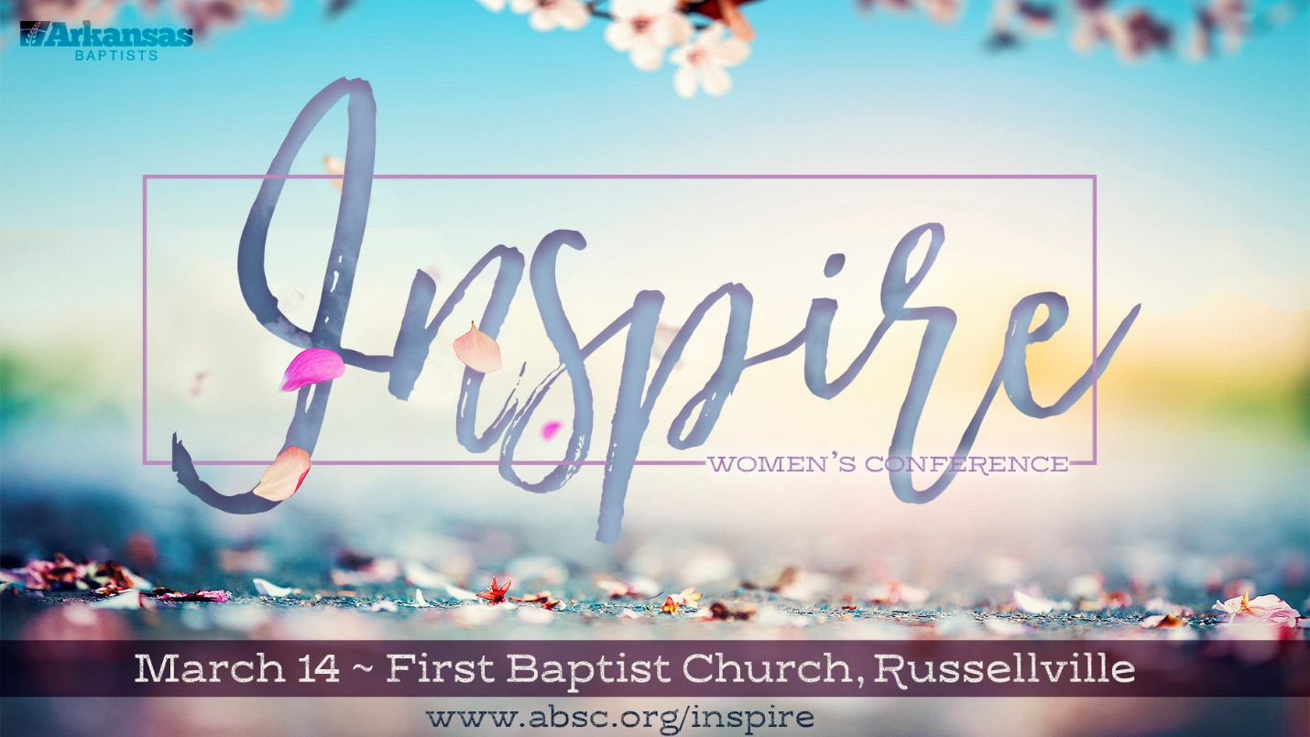

Does the registration fee include lunch? Yes! The price you pay covers a boxed lunch as well as coffee, water, tea, and snacks. If you have special food needs, please email Hillary at hloftin@absc.org.
When is the deadline to register for Inspire? Please register as soon as you can so we can be ready to serve you. We anticipate a sell-out event. The first 900 ladies will get a ticket! The registration deadline is Monday, March 9th by 4:00 p.m.
Is childcare available? I am sorry, we are not able to provide childcare at Inspire.
Can you tell me about the ministry project? Once again, we are partnering with Joseph’s House of Russellville whose mission is to support foster and adoptive families. Learn more at www.josephshouseofrussellville.com. Inspire will be collecting items for the Parent’s Pantry. For a list of items to bring, please access the Ministry Project at www.absc.org/inspire.
Do you have the list of breakout sessions? The breakout sessions are going to be great. You do not want to miss these practical sessions that will help you pursue a God-size vision and focus for life. The complete list is available at www.absc.org/inspire!
Is promotional material available for this event? Yes! You will find posters, a PowerPoint slide, and a promotional video at www.absc.org/inspire. You can download and use these resources to publicize the event.
What time should I arrive? The doors open at 8:15a.m. and the event begins at 9:00a.m. Arrive in plenty of time to check in and visit our muffin & mingle area. Coffee will be waiting for you! This year you will be able to purchase soft drinks.
When I arrive at the church, where should I go? First Baptist Church in Russellville is located at 200 S. Denver Ave. Greeters will be in the parking lot and at the doors. Please enter through the main doors and proceed to the lobby to check-in. (This year we will check to make sure every person has a ticket.) A resource bag will be waiting for you!
Is there a published schedule for the event? Yes! You will find the conference schedule at www.absc.org/inspire.
Are there hotels available in the Russellville area? Yes! We encourage you to book your hotel as soon as possible. Comfort Inn and Suites is offering a discounted rate for Inspire participants.
Is the student rate for high school or college students? The student rate is for anyone in high school or college. We encourage girls who are in 9th grade and above to attend Inspire. This year we are adding a student track for girls in 9th through 12th grade.
What do I need to know about the Student Track? We heard your feedback and we are excited to introduce this new opportunity for 9th-12th grade girls. The girls will attend the Main Sessions with all the women. Then they will have the chance to go to the Student Center for the Girls Track. For this to work, the girls need to attend Inspire with a parent, chaperone, or women’s ministry group. The person who brings the girl are responsible to make sure the girls are where they need to be during the day. A discount rate is available for students. 150 student spots are available at Inspire.
Can I get a refund? All ticket sales are final once the deadline of March 9th has passed. If you request a refund prior to March 9th, we can refund $27.00 due to credit card processing fees.
Can you help me figure out the registration process? Thank you for being patient as we use a new registration process. Here are some helpful tips:
- The price is $30.00 for adult, $20.00 for student.
- Register Students on a separate registration. At payment, enter the code “Student” for the discount.
- During the registration process, you will be asked for the Organization. This field is asking for your Church Name. Make sure to scroll down to the correct church.
- To Search for a First Baptist Church, enter the city name first. For example, Little Rock First Baptist Church.
- To enter more than one person, enter the total number of people in the “# of People” box. Then enter each person one at a time. Please use each person’s own individual email address, not the church email.
- If you have any questions, please call the Arkansas Baptist State Convention. We will be glad to help.

We cannot wait to see you at Inspire!

