**Inspire Breakout Session**

**Titles/Descriptions/Bios**

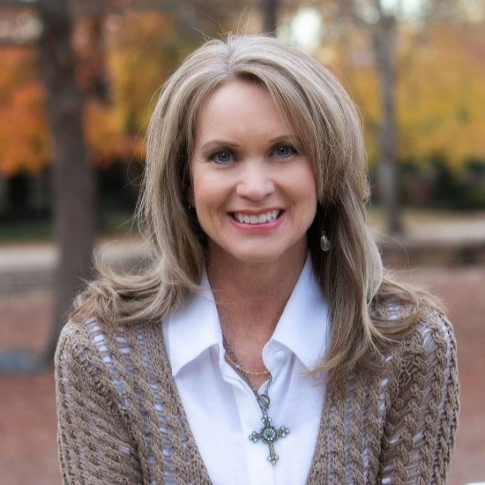

***The Motherhood Journey: Keeping God’s Vision in Sight***

**Shari Edwards**

Let’s face it, mothering is one of the most exhausting, challenging, yet rewarding jobs on the planet! We can find ourselves just trying to get through the details of the days instead of keeping our eyes on the bigger vision of shaping the hearts of our kids over the years. In this session you’ll be reminded of biblical truths and learn practical takeaways for how to catch God’s vision for our kids so they can be released to soar as He created them to!

***Shari has been active in Women’s Ministry leadership for over 20 years and currently serves as Adjunct Instructor of Ministry to Women at Ouachita Baptist University Pruet School of Christian Studies, as well as Chair of the Pruet School Advisory Board. Shari serves as a Lifeway Women Trainer and is currently enrolled in New Orleans Baptist Theological Seminary Leavell College, pursuing a Women's Ministry Certificate. She serves as the Administrative Coordinator for ABSC Inspire Women’s Conference. Shari is a wife of 31 years to her college sweetheart, mother of 3 sons and a beautiful daughter-in-law, and “Sibby” to 2 precious granddaughters. She resides in North Little Rock, AR and is an active member of her church. Shari is the founder of Genesis Girls Ministry and loves to encourage women in leadership and their everyday lives.***

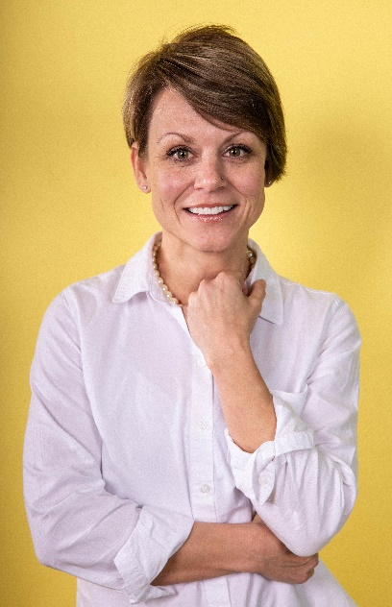***Abiding Prayer: A Guided Time of Seeking God’s Heart***

**Lisa Jones**

Prayer is an invitation from a loving Father who longs for His children to know and walk with Him. “Hear, O Lord, when I cry aloud; be gracious to me and answer me! You have said, ‘Seek my face.’ My heart says to you, ‘Your face, Lord, do I seek.’” (Ps. 27: 7–8)

This breakout session is a time of guided prayer to link hearts with our sisters in Christ to confidently enter the throne room where God's mercy and grace are waiting to be dispensed.

***Lisa Jones is the wife to Todd, mother of 3 sons, women’s ministry coordinator at Beech Street Baptist Church, mother to many spiritual daughters, the daughter to many spiritual mothers and a servant of Jesus. Her cry to believers of all ages is to “Draw near to God, and He will draw near to you.” James 4:8. She seeks to challenge women to live fully in the presence and power of Christ.***

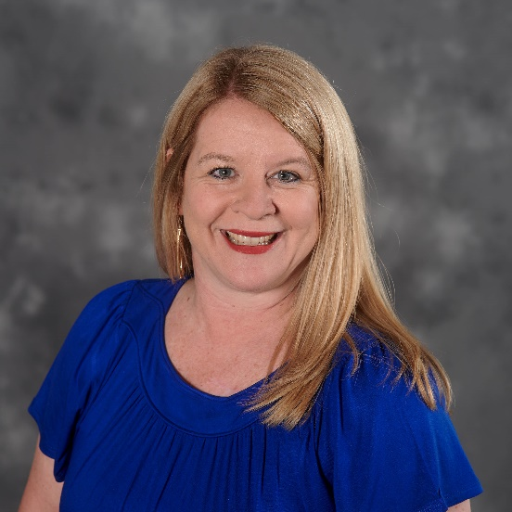***Disciple-making: The Mission of the Church***

**Lesley Hildreth**

Does your church have a culture of disciple-making? In this session, we will discuss what discipleship is and provide practical ideas to help your women grow in their faith and make disciples of others.

***Lesley is the Women's Discipleship Director for the Summit Church in Durham, North Carolina. She is responsible for the discipleship of over 6,000 women spread over ten campuses and spends the majority of her time developing and equipping leaders who share the task of making disciples. Before this role, Lesley was the Assistant Director of Women's Life at Southeastern Seminary where she received her MA in Christian Studies. She also served eight years with her family with the International Mission Board in Western Europe and Central Asia. Lesley also serves as a Lifeway Women Trainer. She has a passion to see all women participating in God's mission, using their gifts to serve the church, further his kingdom, and bring God glory. She is married and has two adult children and one grandson.***

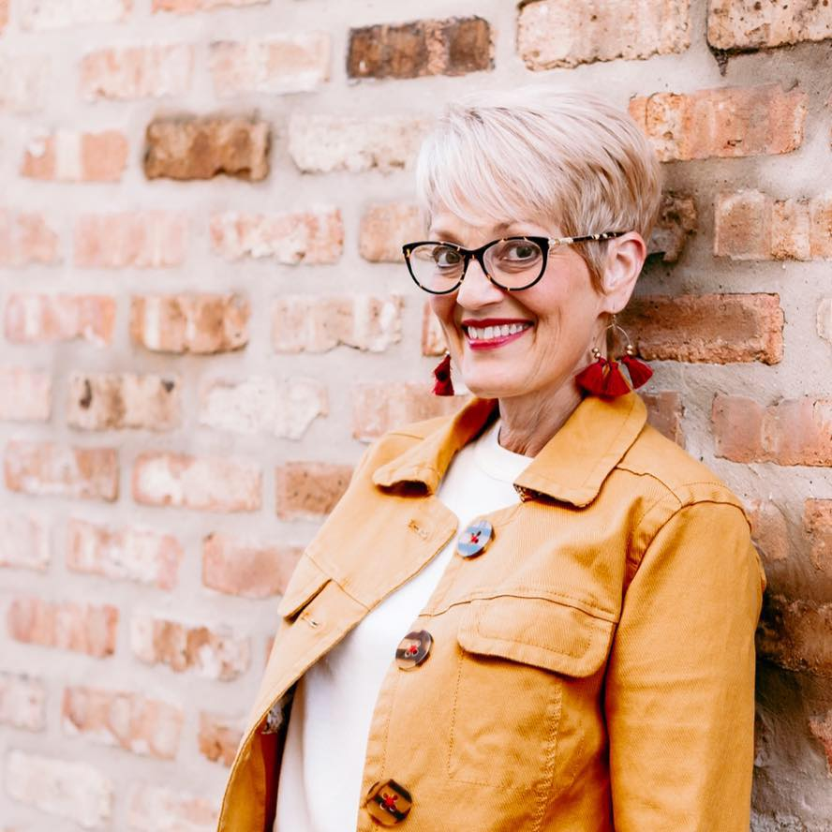

***How Do You See the Water Glass?***

**Sally Hennard**

Do you see the glass half-full or half-empty? Or, perhaps there’s a third option? God tells us to take every thought captive (2 Corinthians 10:5), but how do we do that before thoughts become a part of our heart? Many of us struggle with this especially in our world of high technology and energy. In this session, we will explore practical lessons from the water glass, learning how to have thoughts that are pleasing and obedient to God as we pursue God’s vision and focus for our lives.

**Sally Hennard lives in De Queen with Don, her loving husband of almost 34 years. Together they have four children (one son and three daughters), two sons-in-law, a daughter-in-law and two adorable grandsons. Sally is passionate about encouraging others and helping the hopeless find hope. She has 35 years of experience in secondary education with 28 of those years in the counseling field. Sally is currently a counselor at De Queen High School and loves that she can pour into teenagers. She serves her local church by serving on the praise team, leading a small group along with her husband, and facilitating Precept Upon Precept Bible studies. She and the small group that meets with her have over a decade of Precepts behind them.**

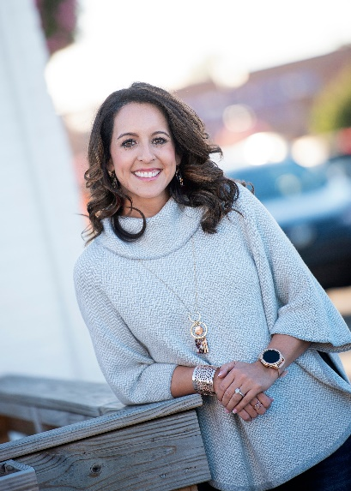***Gaining Christ in a World of False Identities: Philippians 3:1-11***

**Jacki King**

We all want to chase Jesus well but in the journey of faith we often find ourselves swapping our God-given identity for lesser accomplishments and meaningless markers that inevitably leave us longing for more. Together we will learn what it looks like to strip away false identities and pursuits and learn what it means to be a woman who knows, seeks, and chases after "knowing Jesus" with our hearts, minds, and souls.

***Jacki King holds a BA in Biblical Studies and Women’s Ministry from Criswell College in Dallas, TX and is currently pursuing her Master’s Degree in Theology at Southwestern Baptist Theological Seminary. She has the privilege of leading the ministry to women at Second Baptist as well as speaking at women’s and girl’s conferences and retreats across the South. She has a passion for seeing women fall in love with Jesus and His Word while challenging them to be on mission in their homes, workplaces, and communities.***

***In her spare time, Jacki hosts a podcast called “At The Table” which interviews and shares stories of women leaders in the Southern Baptist Convention. One of her big heartbeats is to champion, cheer on, and help develop other women leaders as they chase after the calling God has placed on their lives. We are all so much Better Together!***

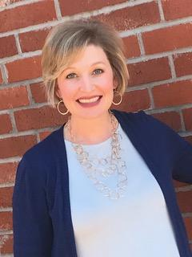***Fear God and Fear Not***

**Shelly Chandler**

Don’t let fear cloud your vision in 2020! Learn the life-changing truths that will alter how you battle fear while living in the light of the all-knowing God.

***Shelly is the founder of GO3 Ministries and lives in Conway, AR, with her husband, Michael, their three boys and their two boy dogs. She is a graduate of Southwestern Baptist Theological Seminary where she received a Masters in Theological Studies. She serves locally at her home church, Central Baptist, as the Women's Ministry Director and also for the state as the Network Ministry Leader for Central Arkansas and the Program Coordinator for the Inspire Women's Conference.***

***Finding God’s Focus for Wives of Ministers***

**Lauren Holley/Cheryl Harp**

Ministry Wives, please join us for lunch and this special session where we will uncover God’s desire and focus for our lives while we serve alongside our husbands, as well as serve our local church body. We will discuss how to deal with disappointments and distractions and turn our focus on God’s calling on our lives as we share His love through the way we live!

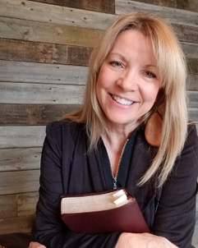

***Cheryl Harp is blessed to be the Pastor's Wife at Lakeview Baptist Church in Cave Springs, AR and considers that to be her great joy and calling on her life. She also serves women in the local church as the Women's Ministry Team Leader and serves as the NWA Women's Ministry Network Volunteer for the ABSC. She loves to dig into scripture and the opportunity to teach and disciple women. She is passionate, humbled, and grateful that God allows her to be a part of His awesome and great work.***

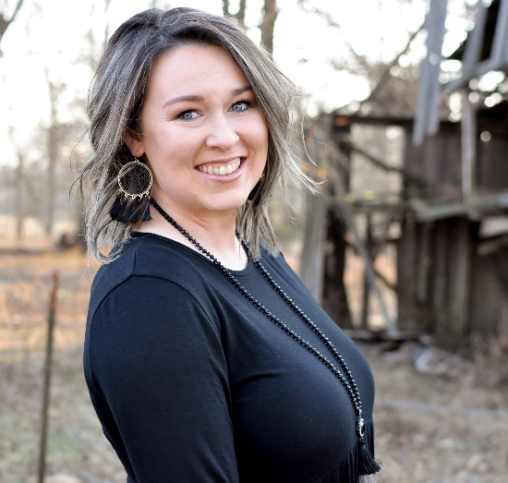

***Lauren Holley has been married to her husband, Jeremy, for twelve years and they have three children. Lauren is a pastor’s wife in Cabot where she also serves as the Women’s Ministry Leader in their church. Lauren enjoys the opportunity to pour into other wives of ministers, and has a strong desire to share God’s Word and make disciples. Proverbs 3: 5-6***

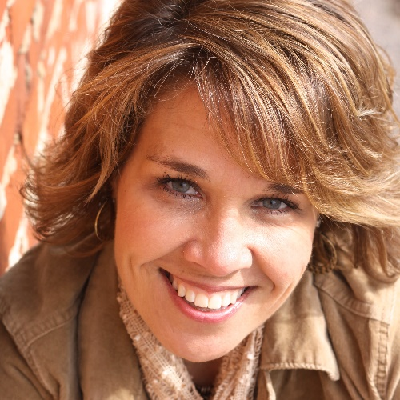

**Lori McDaniel**

***Lori McDaniel is a mom of 3, pastor's wife, speaker, and works at the International Mission Board as manager of the Church Initiatives team. She served with her family as a missionary for several years in Africa before returning to plant Grace Point Church in Bentonville, Arkansas.***

***The Story of Ruth***

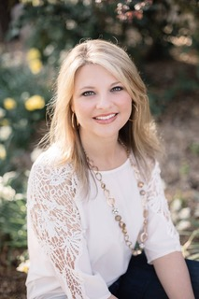**Andrea Lennon**

The life of Ruth provides an example of a woman who pursued God’s vision by focusing on Him even during the difficult moments of life. The outcome? The direction of her life (and ours) changed forever. In this breakout, learn practical ways to embrace God’s vision by focusing on Him so your life and lives of others are impacted for eternity.

***An “on the go” kind of girl who loves Jesus, Andrea is a Bible teacher whose life calling is to teach women to know the truth, live the truth, and share the truth. Her passion is honest conversation about the topics that drive our messy, everyday lives, and how we can always weather the storms through the love and power of God and His Word. Andrea is a 2004 graduate of Southwestern Baptist Theological Seminary. She has written and published several books and teaching DVDs that complement her books. Andrea hosts a weekly radio program called Truth on the Go with Andrea Lennon and a weekly podcast called Inspire on the Go. She serves as the Women’s Ministry Specialist for the Arkansas Baptist State Convention. Andrea lives in Conway, Arkansas with her husband, Jay, and two sons, Jake and Andrew. Connect with Andrea at*** [***www.andrealennonministry.org***](http://www.andrealennonministry.org)***.***

***We’re Still In This - Seeing God’s Best in Relationships***

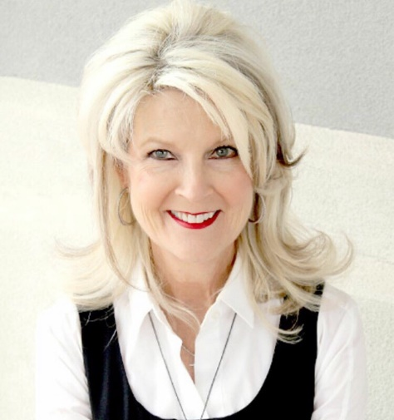**Susan Goss**

We were created for relationships. God, in His genius and creativity, designed us to both need Him and to need each other. The only problem with relationships…is people - right? We can do and say the strangest things to each other. In this session you’ll receive practical, tangible takeaways full of God’s Truth that will strengthen every relationship in your life. Love to see you there!

***Susan Goss is a Licensed Professional Counselor (LPC) , a Licensed Marriage and Family Therapist (LMFT), Founder and Director of Tangible Truth Ministries and Co-Founder of The Joshua Center, a faith-based therapy center based out of Northwest AR. Susan is the author of the book We’re Still in This: 90 Healthy Truths For Happy Relationships, a contributing writer at Celebrate Magazine NWA, guest commentator on KLRC Radio, and produces a weekly video blog called “Susan Shares.” Susan serves on the Board of Trustees at Ouachita Baptist University and the Endeavor Foundation of Northwest Arkansas. Susan is passionate about her love for God and wants desperately for others to know Him too. She is married to Steve, and they have two grown sons, Chad, who is married to Ashley (and they have Adeline 5 and Whit 3), and Jake, who is married to Mariah (no children…yet). Susan’s favorite name to be called..”Honey”. Steve is”Doc”!***

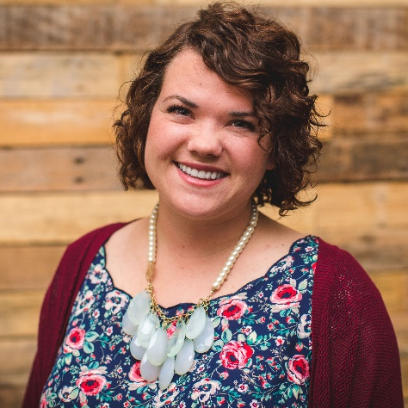***The Inspire Track for Students***

**Whitley Tracy**

***1: Identity Crisis***

Do you ever feel like you’re having an identity-crisis that you aren’t sure who it is staring back at you when you look in the mirror? In this breakout, we’re going to look at three chapters in Genesis to see the very first identity crisis happen. We’ll see how the enemy still uses the same tactics on us today. God, from the very beginning, had a plan to restore identity, not just for Adam and Eve, but for us as well.

***2: Relationship Status***

What does the Bible say about dating relationships? What really matters when it comes to looking for “Mr. Right?” Do my parents really know what they’re talking about when it comes to dating? These are all questions we will tackle in this breakout by looking at the story of Samson and Delilah in Judges 14-16. Whether you’re currently in a relationship, want to be, or think boys are gross, we hope you’ll leave with knowledge from God’s Word to help you navigate relationships now and in the future.

**Whitley Tracy is a small-town girl who grew up on a farm in Cheyenne, OK and is thankful for God’s plan being better than her own. A graduate of Oklahoma State University with a Bachelor’s in Communication Sciences and Disorders, Whitley is continuing her education at New Orleans Baptist Theological Seminary in Girls’ and Women’s Ministry. She has been the Girls’ Minister at Trinity Baptist in Ada, Oklahoma for the past 7 years and has a passion for girls to find their true identity in Christ, as well as all things Girls Ministry and passing that love on to others. Whitley currently serves on the BGCO State Women's Leadership Team and as a LifeWay Women Trainer. In her spare time she loves traveling, hole in the wall restaurants, eating ice cream, visiting her family on the farm, hanging with her youth girls, planting flowers, laughing, and her latest hobby - planning her dream wedding with her wonderful fiancé, Clay.**

***Seeing Others Through the Gospel Lens***

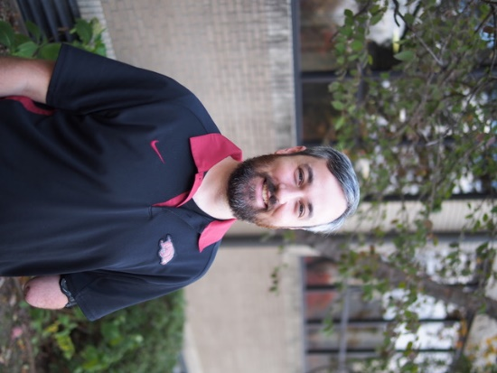**Cole Penick**

Having a Gospel framework helps us to know the Gospel well for ourselves, see the world through its lens, and share it with others. Join us for this interactive breakout where we’ll learn and practice a simple but effective Gospel conversation tool called the Three Circles.

***Cole Penick is the Campus Minister for the Baptist Collegiate Ministry at the University of Arkansas. He has been reaching, discipling, and mobilizing college students at the U of A for over thirteen years. All day, every day, he gets to engage college students with the Gospel. He and his wife, Caroline, and their four kids live right in the middle of campus- their mission field. They enjoy family walks on campus, watching and playing sports, making and eating good food, and oh so many books.***

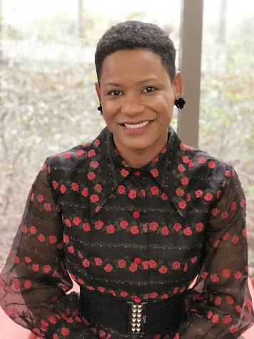***“******To Be Continued” . . . Our Story for God’s Glory***

**Shaneil “P.J.” Yarbrough**

Imagine the finale of your favorite T.V. show with a dramatic cliffhanger…who knows what's to come in the next season? Very much like this, things happen to us and we have to wait because life is “To Be Continued . . . ” See how God can use everything in our lives and our stories to be used for His glory!

**Born in Russellville, after spending time in foster care and adoption, Shaneil grew up in Calion, Arkansas. She is affectionately known as “P.J.” (short for “Precious Jewel”). She is intentional about living life to its fullest and seeks out opportunities to help others realize their potential and excel! Her book, an autobiography, Born a Statistic: Living Rejected, Agreeing with God, shows accessibility to resilience, transformation, God's grace, and unmerited favor! This insightful look into the author's life serves as a testament to how God's immeasurable love supersedes statistical data, rejection, and hesitation to trust His divine plan. For more information, visit www.bornastatistic.com.**

**A graduate of Southern Arkansas University, Yarbrough has a deep-rooted passion for children. She has dedicated nearly twenty years of her life working in several capacities: elementary school teacher, preschool administrator, advisor, coach and professional development trainer. Her current employer is Arkansas State University, Childhood Services. She is a Project Program Specialist supporting Pre-K Administrators across the state.**

**She is zealously involved in both her local church and the community. Currently, she serves as the Vice President of the El Dorado School Board of Education and volunteers as a mentor for young girls. Local youth named “P.J.” the 2018 Mentor of the Year. More recently, in 2019, she was named Community Leader of the Year by another local organization. Life brought P.J. “full circle” as she formerly held the position as the Executive Director and Administrator of Agape House Children’s Home, Inc., a group foster home.**

**Her hobbies include spending time with family, reading, writing, and thrift shopping for vintage clothing. “P.J.” has been married to her husband, Larry D., Sr., Pastor of Changing Lives Ministries, since 2000. They reside in El Dorado with their two sons, Larry D. Jr., “L.J.,” and Lance.**

***Strategic Community - Navigating Each Season with a Vision for People.***

**Abby Turner**

No matter what season of life you find yourself in; loneliness is a key tactic for Satan to use to keep us from seeing God's vision and purpose for our life.  God created us with hearts that desire community. But what happens when community is exhausting, when it fails you, when you don't have it? You will leave this session with practical steps to implement a community-first mentality to grow deeper with God, to see His vision for your season of life, and bring glory to God through serving others first.

**Abby is a somewhat-young professional who is single and loving life as a food blogger, speaker, and writer.  She encourages women to challenge the cultural-stereotypes of singleness and loneliness and that through any season of life community should be intentionally developed and protected.**

**Abby grew up in Central Arkansas to a large family where she learned the importance of community and was taught Biblical Hospitality at a young age.  After completing undergraduate degrees at Ouachita Baptist University and obtaining her Master's from Baylor – Abby lived in 6 states in 5 years learning that community is essential to a healthy relationship with Christ.  This journey led to the birth of her blog; A Table Top Affair.**

**Her goal plainly put is to encourage people in any phase of life - that community is God's providence for loneliness and biblical hospitality is the gateway to easy community.**

**Over the last few years, Abby has spoken to college/universities, churches, companies and has been featured on regional TV shows and podcasts.**

**Her passion is in the connecting of people.  Abby wants to be able to encourage women to stop wasting time waiting for the perfect family, house, or table and to start opening your home, cooking for friends and building community.**

**Abby lives with her two Papillons, Baylor and Mowgli in Northwest Arkansas.  She enjoys a Peppermint Latte almost every morning and can't wait for the Olympics this summer!  Oh, and her cutting board collection could rival Martha Stewart's!**