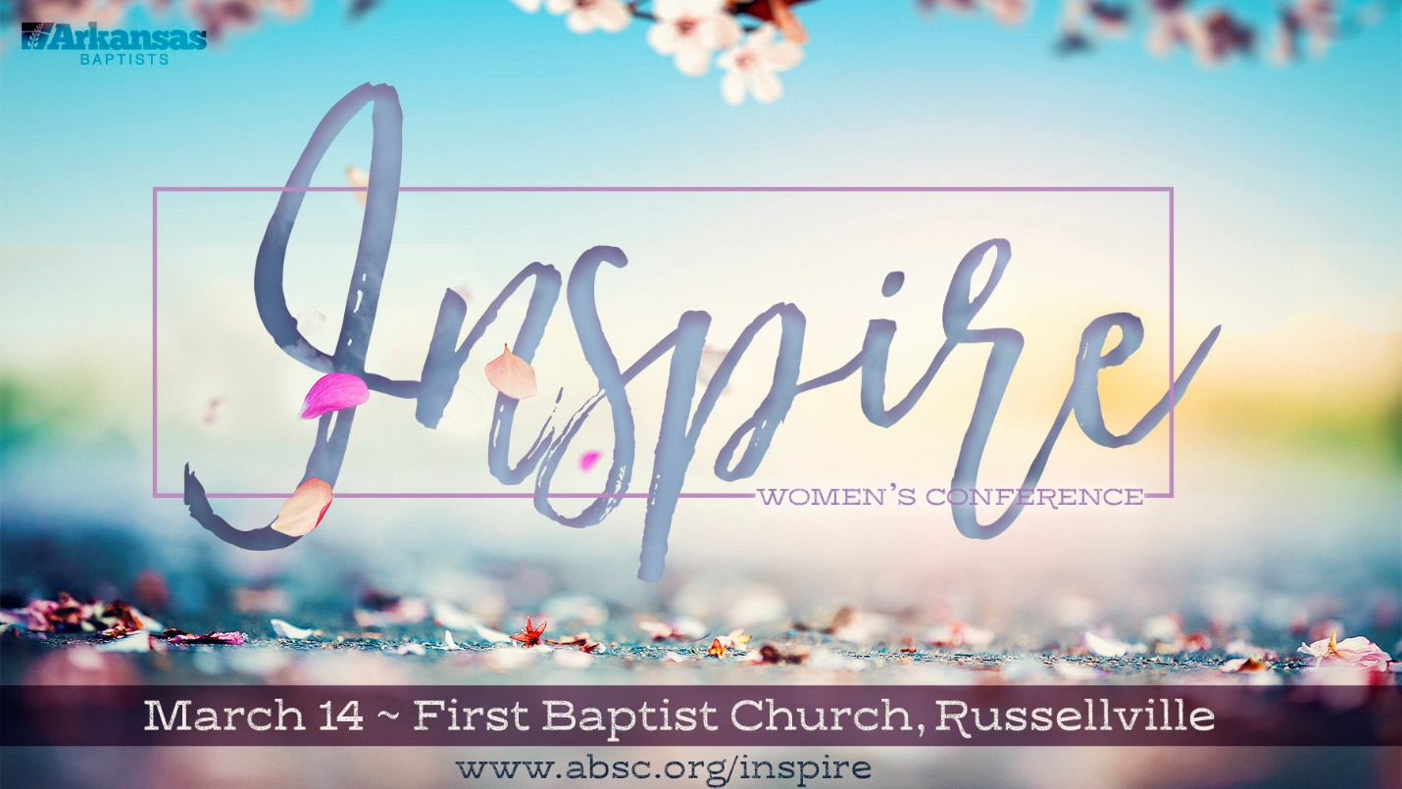
Help us support the work of Joseph’s House by bringing any of the following items and placing them in the collection bins located around the church.
Baby wash
Baby lotion
Diaper cream
Diaper ointment
Diapers sizes 4, 5, or 6
Hairbrushes
Ethnic Hair Products
Tooth paste for Adults & Kids

